Distance Determination Research

Project: Social Buddy

Name: Khizer Butt

Table of contents

* Problem description
* Tracking technology
* Tracking device
* Elaboration Choice of Module
* Conclusion.

*Problem Description*

The Social buddy is an interactive virtual bot which is used by elderly patients that are not able to function independently. It can be accessed via an app which is optimally suited for Android Tablets. Patïents can benefit from this by receiving reminders for medication, and more. The Social Buddy must also be able to keep track of the distance between the patient and itself.

To do this the patient must carry a small tracking device, which is always connected to the Social Buddy. In case the patient walks too far away from the Social Buddy, it must notify the caregiver about this.

*Tracking Technology*

We have two main technologies at our disposal. Ultra-wide band, Bluetooth and GPS. In order to decide which one suits in this case, the requirements of all technologies must be taken into account.

Bluetooth technology only requires Bluetooth support on the devices that need to be connected. Most tablets these days do support Bluetooth and there are enough tracking tags which run on Bluetooth.

Ultra-wide Band (UWB) requires a little more. To utilise this technology both devices need to have UWB support in some way. Tablets usually do not have any UWB built into them. So, to make UWB available to that tablet, an external UWB-transceiver is required. As far as tracking devices are concerned, there aren’t many tracking-tags which support UWB and Android. Only Apple AirTag has UWB support, but it only works in the Apple ecosystem.

GPS technology uses satellite connection to position a device anywhere on the planet. Most tablets have GPS functionality built into them, so it won’t have any external factors to rely on. There are trackers that use GPS only, but these are not that common and have a relatively higher price tag.

If we forgo the costs that these technologies bring with them, then GPS would be the most suitable option, for its efficiency and reliability regarding global positioning. But in this case the Bluetooth option suits us the best, considering the devices that utilise this technology are much more accessible for purchase and doesn’t rely too much on external accessories, and falls under our budget.

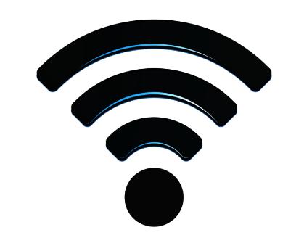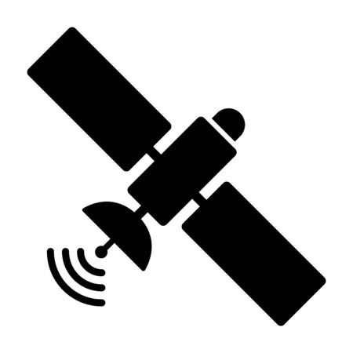

*Tracking Device*

Now that we have chosen Bluetooth technology over UWB and GPS, we must choose a tracking device that has Android Support.

Apple AirTag will fall off the table considering we need Android support. The other option we have is the Samsung SmartTag. This supports Android devices, but exceptionally Samsung devices. Considering we need a device that is compatible with all android devices, this option becomes irrelevant as well.

The third option is the Tile Pro tracker. This is a tracking device which runs on Bluetooth and supports all android devices. Additionally, it has a removeable battery and has a battery life of one year. It has a functioning range of well over 100 metres.

There weren’t many Tracking Devices that satisfy the criteria we have set with regard to the technology and OS support. Fact of the matter is that we only found the Tile Pro as the potential candidate for this application, so there weren’t any competitors in this case.

